**Texan Success- Red Ribbon Week -Monday- October 22**

* Good things
* Watch this short video clip to introduce the history of Red Ribbon week (How it started) <https://www.youtube.com/watch?v=fnotLcPt5q4>
* Ask scholars to quick write…List three facts about the history of Red Ribbon Week. Then ask them to share their facts with a partner.
* After the quick write scholars will read the article “Kiki and the History of Red Ribbon Week” (see attachment) to familiarize themselves more with Kiki and his background.
* You can have scholars work in groups of 4 and assign them a different paragraph each and have them create a summary on the back.
* Hand out Red Ribbons and Bracelets
* Launch- “Team Up Against Drugs”

**Texan Success- Red Ribbon Week Tuesday - October 23**

* Good Things
* Introduce today’s lesson with this video

<https://www.youtube.com/watch?v=JD216CM7iBs&list=PLOQaTwohzeZSIt4qKTvdhXwqA-e7d7-lX&index=4>

* “Making up Your Own Mind” Activity

Using the worksheets attached below you will separate your classes into groups of 3-4. Each group will be assigned a different scenario. Have the students write several solutions for their scenario. Afterwards, have the group’s role-play one of the solutions. Lead the applause after each role-play. (see scenarios and questions below)

* Launch- “Life is your Journey - Travel Drug Free”

Scenario #1

Kirby has been invited by some girls in her class to go to a party. Her friend Patsy asks Kirby to go roller skating the same night as the party. Kirby is excited about the party because some middle school boys will be there, but she overheard the girls talking and knows the girls are going to try smoking. She wants to make new friends, but she doesn't want to smoke. What can Kirby do? Tell how she might handle the situation.

What choices does Kirby have?

Is there a way she could make friends with the girls and not smoke?

What might Kirby say to Patsy?

What might she say to the other girls?

Scenario #2

Brady is behind in his homework because he was sick and missed three days of school. As he leaves hockey practice, Stephen calls out to him. Stephen and two friends are going to the mall to hangout after school. Brady would like to be friends with Stephen and the other boys. What can Brady do? Tell how he might handle the situation.

What choices does Brady have?

Is there a way he can do other things?

What might he say to Stephen?

Scenario #3

Donna's best friend Stefanie has asked her over to her house after school to watch a movie. Her parents will be at work. Stefanie finds a beer in the refrigerator at her house and wants Donna to try some with her. Donna really wants to be friends with Stefanie. What can Stefanie do? Tell how she might handle the situation.

What choices does Donna have?

What could Donna say to Stefanie at the house?

What should Donna do if Stefanie decides to try the beer?

**Texan Success- Red Ribbon Week Wednesday-October 24**

* Good things
* “Choices activity”

Engage the scholars in a discussion about choices and the kinds of choices we make every day. We make dozens of choices in a day or sometimes a dozen choices in an hour or a few minutes. Some choices are more important than others.

Arrange the furnishings to create an open space where all the students can stand. Create an imaginary line down the middle of the space. Explain that you will name two options and they will have to choose one.

As you name the first option you will point to one side of the line and as you name the other option you will point to the opposite side of the line. Everyone must choose one side or the other. Allow scholars to change sides.

Choices to ask your scholars- pizza or tacos; tacos or hamburgers; watching TV or listening to music; getting a new bike or going to camp; going to the movies or going skating; sleeping over at a friend's house or going out to dinner at a great restaurant with the family; math or science; cold or hot; lunch or breakfast

* Have the scholars complete the post-test attached after the activity.
* Afterwards, explain that even when our friends don't pressure us to do something or pressure us to change our minds, we may put pressure on ourselves to be like them.
* Have scholars sign the “pledge” NOT to do drugs before leaving class. (see attachment)
* Launch - “Use your SUPER Powers to STOP Drug use”

**POST-TEST**

**IT’S MY CHOICE**

* What happened in this activity? Did everyone make the same choice?
* How did it feel when you made a different choice from your friends?
* Did anyone change their choice so they could be with his/her friends?
* Can you make a different choice from a friend and keep your friendship?
* When could making the same choice as a friend cause a problem?
* When could making the same choice as a friend be dangerous?

**Texan Success- Red Ribbon Week Thursday- October 25**

* Good things
* Watch this short video to introduce the effects of alcohol on your body and brain.

<https://www.youtube.com/watch?v=g2gVzVIBc_g>

* Discussion: “When you put alcohol into your system there are physiological changes you have no control over. When you use alcohol, one such change is in the area of balance. No matter how hard you try, when you are under the influence of alcohol, you will not be able to physically perform the same activities that you could when there wasn't alcohol in your system. This activity is one of the tests that law enforcement officers will give to a driver that they feel is under the influence.”
* Straight Walking Activity

Have one scholar come up to the front of the group. Explain that they are to walk as quickly as they can, but when they take each step their heel must touch the toe of the foot that is on the ground. When they get to the end of the line, they are to turn around and walk back.

Demonstrate this to the student so that he/she will understand and the class will see what is to be done. Now have the student repeat what you have demonstrated. This will give you a baseline to compare how he/she performs when under the influence. Since the scholar should not drink, do the next best thing. Get the student dizzy. This affects the inner ear equilibrium in much the same way that alcohol does.

Bring the scholar back to the start of the line and spin him/her around enough times that he/she becomes dizzy. Now point the student in the right direction and have the student repeat the activity just as he/she did before. (Do this with 3-4 students)

Make sure you have an open space in your room to do this for safety reasons. If it is a nice day you can always do this outside. :)

* Turn and Talk questions

How did the scholar do the first time he/she tried this activity?

How did the scholar do the second time he/she tried this activity?

How do you think this would affect a person trying to drive a car?

What are some of the other activities that a person couldn't do when he/she was under the influence?

Would you want to ride in a car with a person who is under the influence?

How would you say "no" if someone who had been drinking offered you a ride?

* If time permits, brainstorm as a class and write on the board other negative symptoms and effects of drugs and alcohol other than dizziness.
* Launch- “Rally for the Home Team -BEAT Drugs!”

**Texan Success- Red Ribbon Week Friday- October 26**

* Good things
* Above the Influence

<https://www.youtube.com/user/abovetheinfluence>

* “Avoiding the Trap” Activity

Print out [spider web](http://www.preventionpartners.com/stuff_ex/avoid_trap_ex.cfm) (see attachment). Engage the scholars in a discussion about how spider webs work and why insects don't see the webs until they are caught in them. Webs are not easy to see unless you are looking for them. To be safe, insects must be aware and watch out for webs. Unwise choices can trap us in situations that are like spider webs. Sometimes they are not easy to see. To be safe, we must be aware and watch out for situations that are like webs that can trap us.

Explain that once in the web or situation, the insect must face the consequences, and once in a negative situation, people must face consequences too. Form pairs. Using the handout, instruct pairs of students to decide on and write a sentence describing a situation that could "entrap them in a situation that could cause them trouble or endanger them." Ask each pair to read their situation aloud to the class. Engage the class in brainstorming how to be aware of and avoid the situation. Ask them to name alternative choices and how friends can help friends avoid "the trap."

* Turn and talk/whole group questions

How is making an unwise choice like being trapped in a spider web?

What is one way we can avoid being trapped in a negative situation?

How can we help our friends avoid trouble or dangerous situations?

Does a friend encourage a friend to make choices that could be dangerous?

* (Extra time) “Pursue your passion, stay drug free” video

<https://www.youtube.com/watch?v=nN1egg0ptTA>

* Launch- “No room for drugs in my future -I’m going to COLLEGE.”

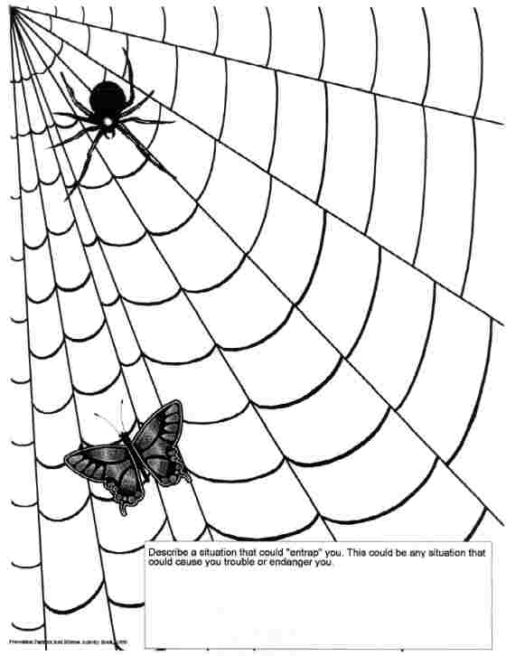

**ALTERNATE ACTIVITY for FRIDAY**

**GOALS FOR THE FUTURE**

**Objective:**

* **To help youths look at their lives with broader perspective and establish goals for the future.**

**Background:**

* **Adolescents in grades 7-8 are very concerned with the present. Youths who use or sell drugs usually are seeking temporary thrills, escape from problems, acceptance from peers, or fast money-all of which are of more immediate importance than their future and the harmful consequences of drugs.**

**Activities:**

* **Draw a time line on the board and have students copy it on a piece of paper. Label the left terminus Birth and the right terminus The Future, ending in an arrow. Divide the time line into segments according to stages of life (examples: Infancy, Early Childhood, Childhood, Pre-adolescence, Adolescence, Young Adulthood, Adulthood, Middle Age, Old Age).**
* **Explain that each person's life is like history itself: filled with mundane daily happenings that are sparked by extraordinary events that change the course of life. Examples of such events: learning to walk and talk, entering school, learning to read, winning a competition, learning a sport, graduating from high school, getting a good job, having a family, and so on.**
* **Ask students to note on their time lines important events that have occurred in their lives. Then ask them to fill in the rest of the time line with specific goals they would like to accomplish. Invite a few students to put their time lines on the board.**
* **Discuss a few of the time lines and the efforts involved in reaching some of the goals students have identified. Point out the value of looking at life as a continuum, with accomplishments creating the foundation for future accomplishments.**
* **Discuss the following:**
  + **Why is it a good idea to outline life goals?**
  + **What does it take to make goals and dreams become reality?**
  + **What effect would using or selling drugs have on your ability to reach your goals and dreams?**
  + **What can you do this week (month, year) to help you reach your goals?**

**Teacher Tips:**

* + **Discuss how our nation's leaders have affected history. Example: The Rev. Martin Luther King, Jr. and the civil rights movement. Suggestion: Read and discuss King's "I have a dream" speech, and discuss how it relates to setting goals for the future.**

**Source**

* **Learning to Live Drug-Free, A Curriculum Model for Prevention, U.S. Department of Education's Safe and Drug-Free Schools Program**